ifconfig -a 看ip…並記住
新增 phpMyAdmin 管理套件
- mkdir /home/update
- 用 winscp copy phpMyAdmin 資料夾-> /home/update
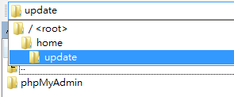
- cp -r /home/update/phpMyAdmin /var/www/cacti
- cp /var/www/cacti/phpMyAdmin/libraries/config.default.php /var/www/cacti/phpMyAdmin/config.inc.php
- vi /var/www/cacti/phpMyAdmin/config.inc.php
39 $cfg['PmaAbsoluteUri'] = 'http://A.B.C.D/cacti/phpMyAdmin';
151 $cfg['Servers'][$i]['auth_type'] = 'http';
- 進入http://IP/cacti/phpMyAdmin 輸出 host & settings
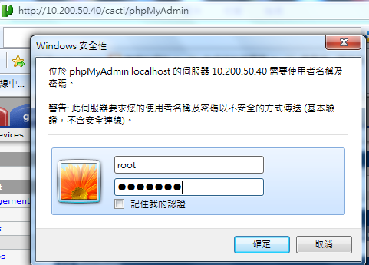
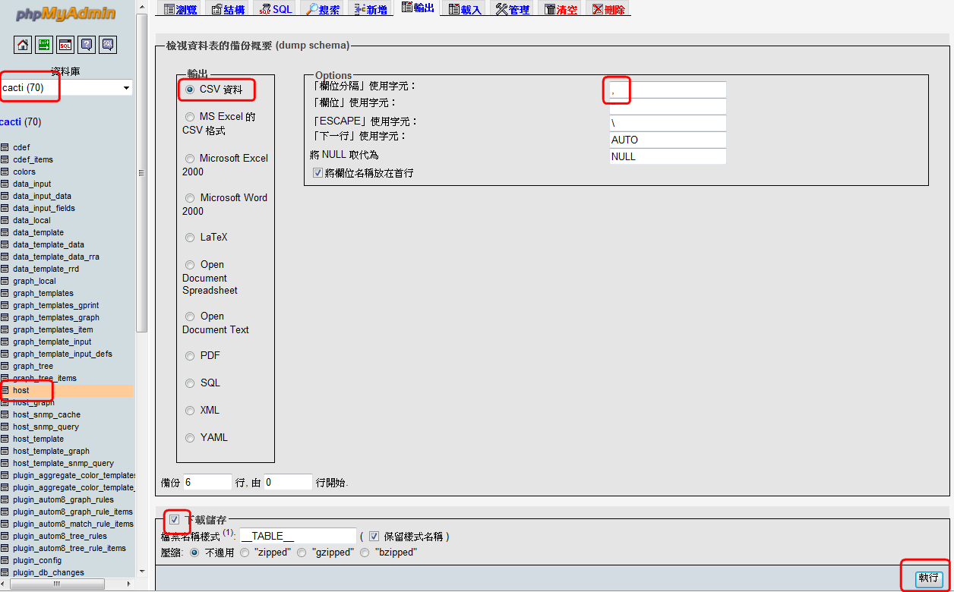
- 匯入前先拿掉第一行說明…
- 進入 http://IP/cacti/phpMyAdmin 載入
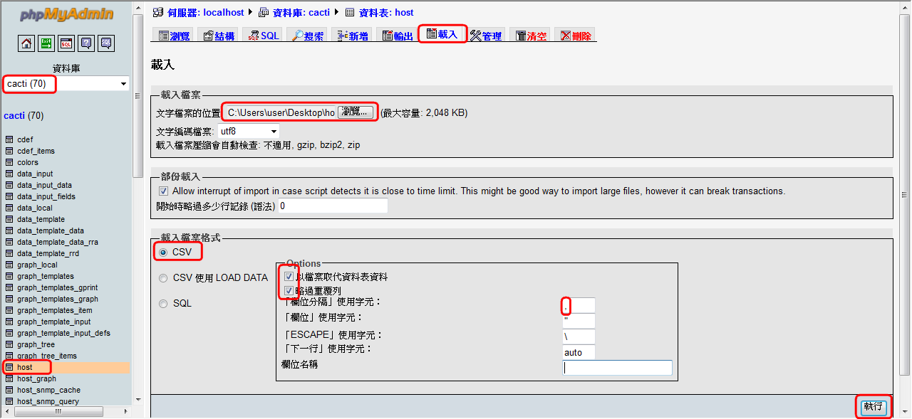
- settings -> 將 ping_failure_count 改成 “4”
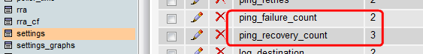
結果得知 ----------------------------------------------------------------------------------------------------------------
UPDATE `cacti`.`settings` SET `value` = '4' WHERE CONVERT( `settings`.`name` USING utf8 ) = 'ping_failure_count' LIMIT 1 ;
------------------------------------------------------------------------------------------------------------------------------
- Save in /home/change/change_to_4.sql
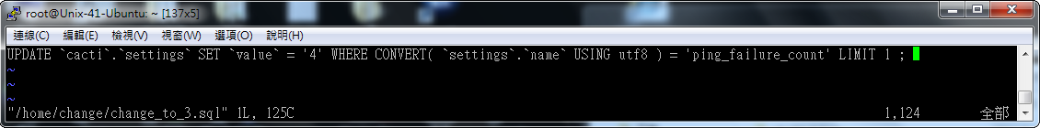
- mysql -uroot -pdbadmin cacti < /home/change/change_to_4.sql
檢查網頁是否異動 ?
- Save in /home/change/change_to_4.sql
- echo "0 8 * * 1-5 root /usr/bin/mysql -uroot -pdbadmin cacti < /home/change/change_to_4.sql" >> /etc/cron.d/cacti

設定系統 logrotate
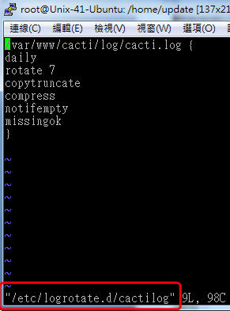
- vi /etc/logrotate.d/cactilog
/var/www/cacti/log/cacti.log {
daily
rotate 7
copytruncate
compress
notifempty
missingok
}
- logrotate /etc/logrotate.conf -v
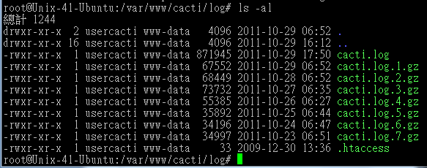
備份與復原
- vi /var/www/cacti/backup.sh
#!/bin/sh
PATH=/bin:/sbin:/usr/bin:/usr/sbin:/usr/local/bin:/usr/local/sbin:~/bin
export PATH
day=`date +%Y-%m-%d`
mysqldump -uroot -pdbadmin -l --add-drop-table cacti > /home/backup/cacti/mysql.cacti."$day"
mysqldump -uroot -pdbadmin -l --add-drop-table syslog > /home/backup/cacti/mysql.syslog."$day"

tar -jcvf /home/backup/cacti/html."$day".tar.bz2 --exclude=/var/www/cacti/rra* --exclude=/var/www/cacti/log* /var/www/cacti
find /home/backup/cacti/* -type f -mtime +15 -exec rm -fr {} \; > /dev/null 2>&1
- chmod 755 /var/www/cacti/backup.sh
- /var/www/cacti/backup.sh
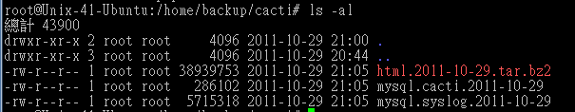

新增Cisco Interface Status模組
- 下載與匯入模組
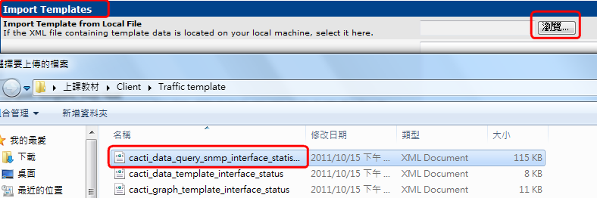
- 確認更新的套件
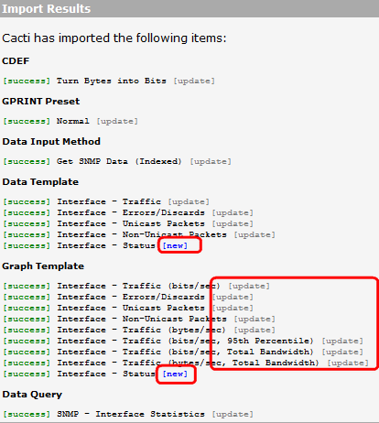
- 分析模組內容
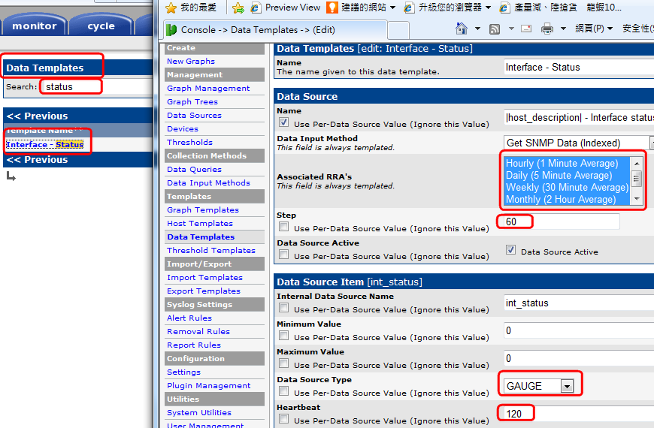
- 測試與上線
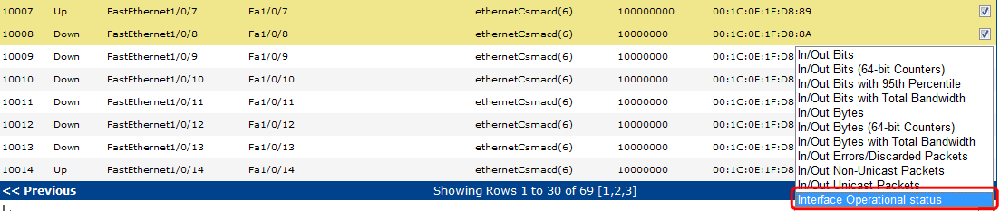
- 出圖與數值確認
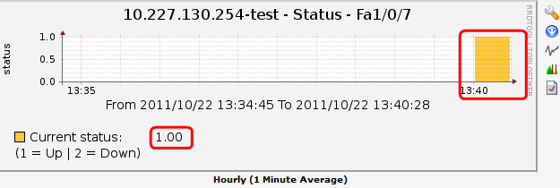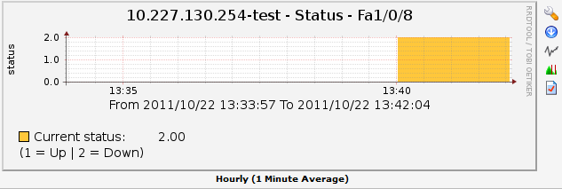
- 更改單一圖形顏色與大小。更改全部圖形顏色與大小
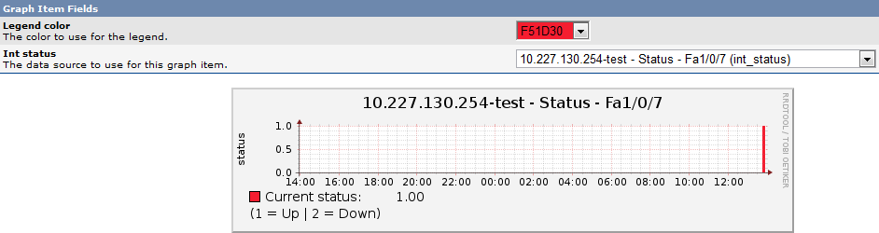
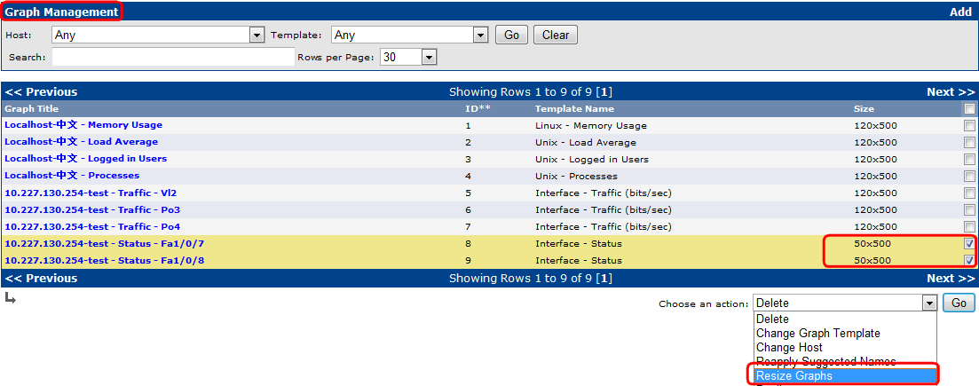
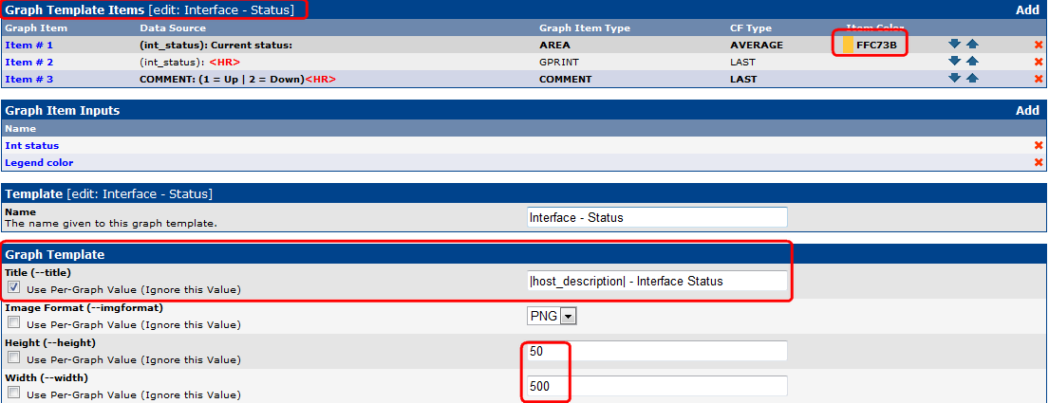
- 建立單一DS(RRD資料)的THOLD/建立大量DS 的THOLD圖形資料
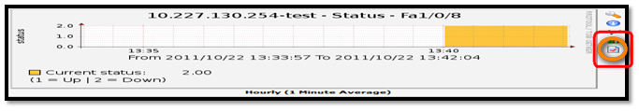
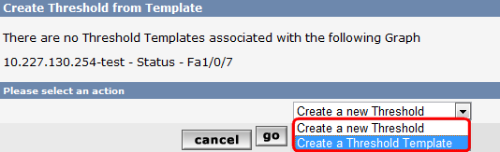
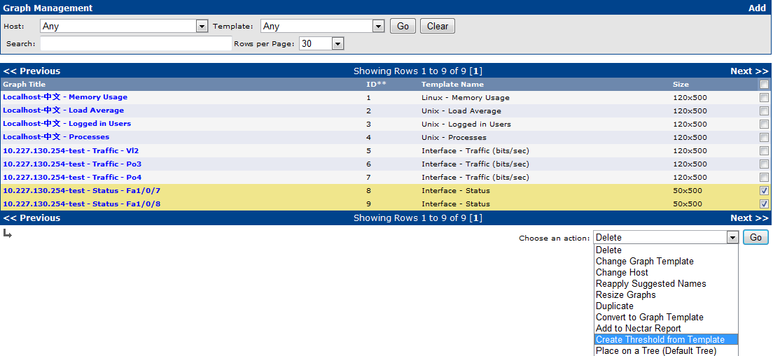
- 建立Aggregate
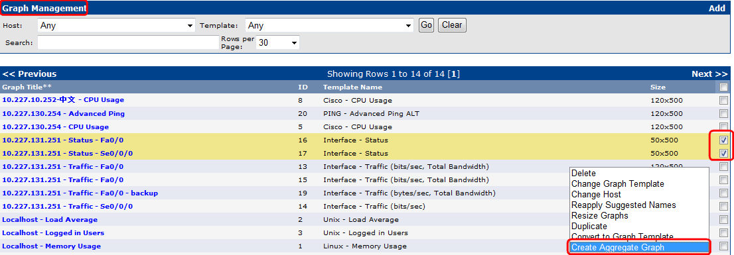

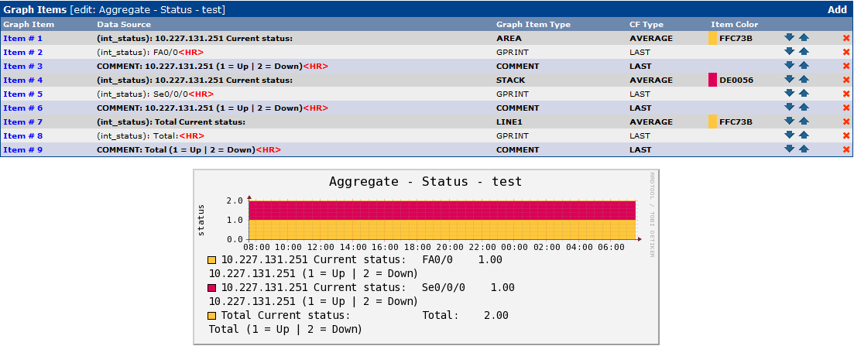
- 建立CDEF
http://forums.cacti.net/viewtopic.php?f=5&t=43923&hilit=CDEF+color+change
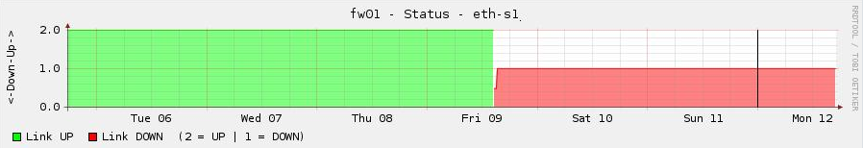

Flow1.1 安裝
- 下載檔案/解壓縮-上傳至伺服器
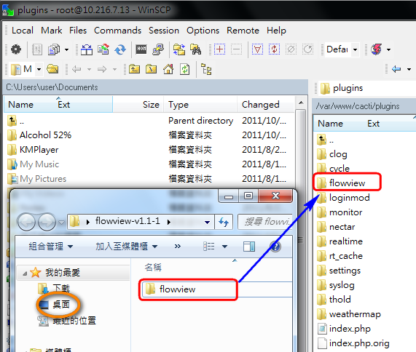
- 更改權限
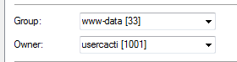
- 主機-導入資料庫
cd /var/www/cacti/plugins/flowview/
mysql -uroot -pdbadmin cacti < flowview.sql
php setup.php
- 網頁-啟動服務
- 調整設定檔
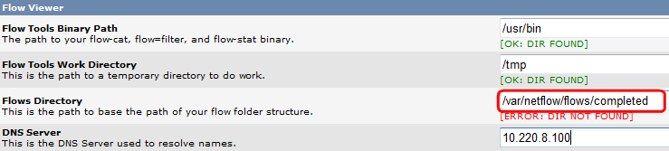
- 主機 – 建立對應資料夾 completed
mkdir -p /var/netflow/flows/completed
- 網頁設定
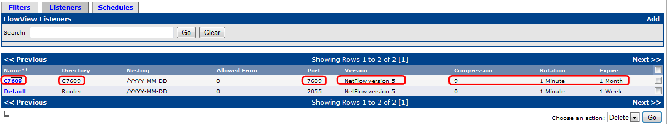
reboot->確認資料會被保留
- 主機 – 建立對應資料夾 C7609
mkdir /var/netflow/flows/completed/C7609
- 安裝 flow-tools
dpkg -l | grep flow-tools
apt-get install flow-tool*
reboot
ps axu | grep flow
- vi /etc/rc.local
/usr/bin/flow-capture -w /var/netflow/flows/completed/C7609 0/0/7609 -S5 -V5 -z 9 -n 1439 -e 43200 -N -1
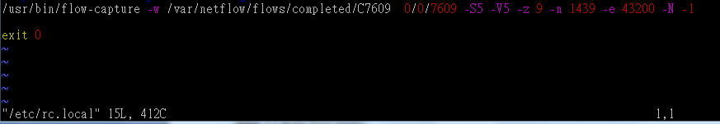
reboot
ps aux | grep flow
- Router 設定
Router(config)#ip flow-export destination 10.216.7.13 7609
- 主機確認資料
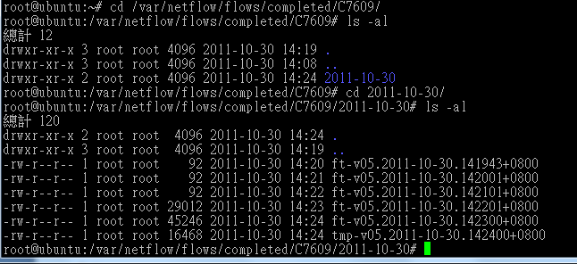
- 網頁設定
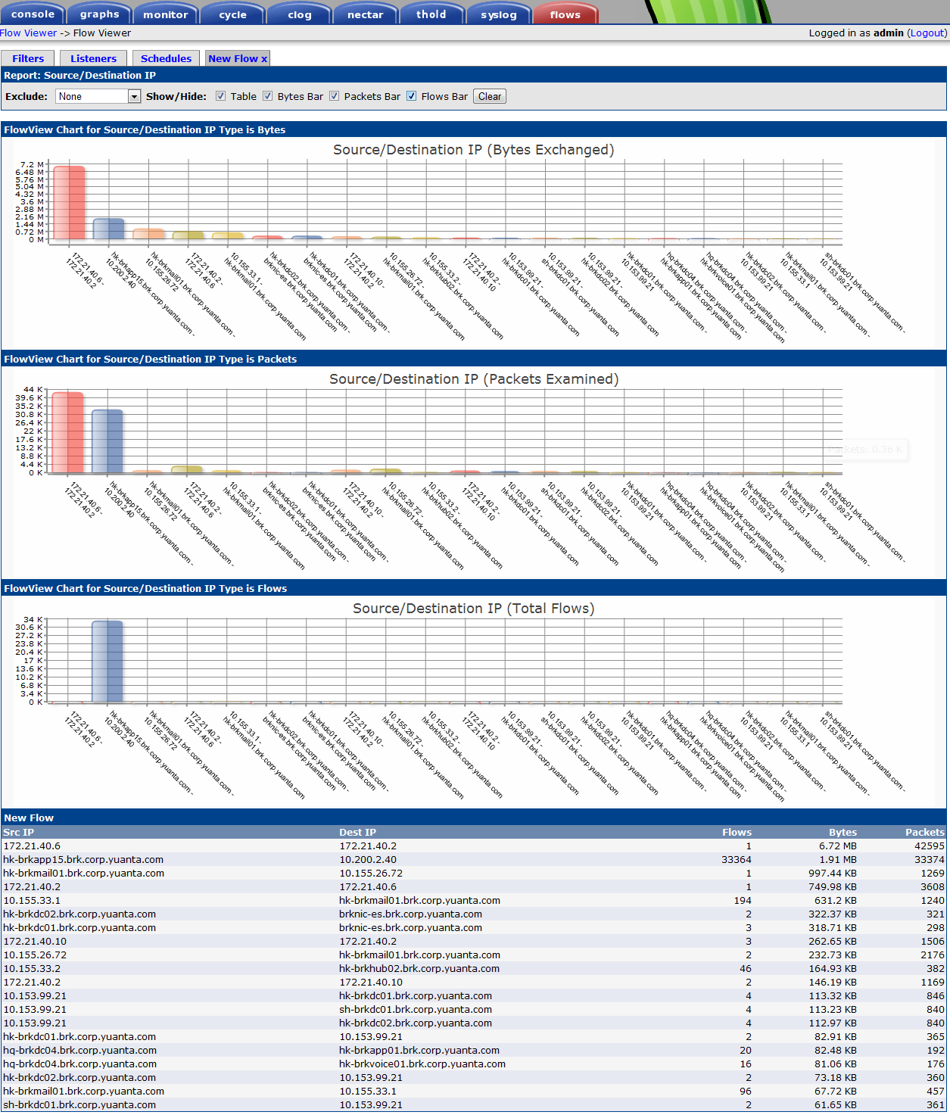
Router Command-----------------------------
(config)# ip flow-cache timeout active 5
(config)# ip flow-export source
(config)# GigabitEthernet0/1
(config)# ip flow-export version 5
(config)# ip flow-export destination IP Port
(config)# ip flow-top-talkers
(config)# top 50
(config)# sort-by bytes
介面-----------------------------------------------
(config-if)# ip flow ingress
(config-if)# ip flow egress
OR
(config-if)# ip route-cache flow
指令-----------------------------------------------
sh ip flow-top-talker

Flow v0.6 版
做法同上。可以儲存。輸出。

User Add管理

